Template for AMTA 2025 Symposium
Rogelio L. Rivert^{1,} MEMBER, AMTA, and Jeff Smith^{2,} FELLOW, AMTA

Antenna Measurements Center (AAMC), Florida, U.S.
- MACOM Systems, Tadam, Wisconsin, U.S.

Abstract—This electronic document serves as a “live” template and outlines the most important sections of your paper within its style sheet. For AMTA 2025, it is crucial that both the abstract and final paper undergo a peer-review process to ensure high quality. A minimum of three reviewers will evaluate your submission and provide valuable feedback on your proposed manuscript. Quality is essential, and we encourage you to take this review process seriously to enhance the overall standard of your work. In a full paper the IEEE abstract is a concise summary of a research paper, typically ranging from 150 to 200 words. Abstract should clearly state the main objective of your research, outlining the problem you are addressing. Briefly describe the methodology or approach used in your study, followed by a summary of the key findings or results obtained. Finally, highlight the significance of your findings and their implications in the field. Use clear and concise language without jargon and avoid citations or references in the abstract. Consider including keywords after the abstract to enhance discoverability. By following these guidelines, your IEEE abstract will effectively communicate the core aspects of your research.
Index Terms—antenna, calibration, compression, robotic, UAV. (order the keywords alphabetically)

Introduction
An introduction in an IEEE paper should be structured to effectively set the stage for the research presented. Begin with a broad context, outlining the general area of study to draw the reader’s attention and highlight the significance of the topic. Next, identify specific problems or gaps in existing literature that your research addresses, making a case for why these issues are important. Follow this with a brief overview of your approach or methodology, indicating how it contributes to addressing the identified gaps. Clearly state the objectives of your research, outlining the main contributions or findings you intend to present. Finally, end the introduction with a roadmap of the paper, giving readers an overview of the structure and what to expect in the subsequent sections. This logical flow not only engages the reader, but also provides clarity on the purpose and direction of your research [1], [2], [3], [4], [5].

Adherence To IEEE Standards And AMTA 2025 Guidelines
For AMTA 2025, it is crucial that authors adhere to the highest standards of quality as outlined by AMTA and IEEE for the peer- review process. Submissions must be prepared with precision and professionalism to ensure clarity, consistency, and compliance with IEEE formatting requirements. Authors are expected to follow these key principles:
  - IEEE Formatting Standards: All manuscripts must be formatted in the standard IEEE two-column, single- spaced layout, using 10-point Times New Roman font. Authors should also follow the IEEE heading styles and include references in the appropriate format.
  - Guidelines for AMTA 2025: Authors must strictly ad- here to the formatting and submission guidelines provided in the official AMTA 2025 template. This includes proper structuring of sections, accurate citation formatting, and ensuring that all figures, tables, and equations are presented clearly and legibly.
  - Quality and Clarity: Submissions should be written in clear, concise, and grammatically correct English. The content must be well-organized, with logical flow and coherence, to facilitate the peer-review process and ensure the paper’s readability.
  - Compliance with Ethical Standards: Authors must ensure that their work complies with IEEE’s ethical standards, including proper attribution of sources, avoidance of plagiarism, and accurate representation of data and results.
By following these guidelines, authors contribute to maintaining the high standards of quality expected for AMTA 2025 submissions. Please refer to the official template and instructions provided to ensure your manuscript meets all requirements.

Author’s List and Affiliations
For AMTA Symposium 2025, please follow these guidelines for formatting the authors’ list and affiliations:
  - Authors’ List: The authors’ names should be presented in a single row, with each author separated by commas. Each author’s name must include a superscript to indicate their affiliation, followed by their ORCID identification.
  - Affiliations: Affiliations should be listed in a second row. At the beginning of each affiliation, include a numerical identifier in parentheses that corresponds to the superscript in the authors’ list. After the affiliation, and separated by commas, include the state and country.
  - Formatting Example: Please use the formatting pro- vided in the template example to ensure consistency and adherence to the guidelines.

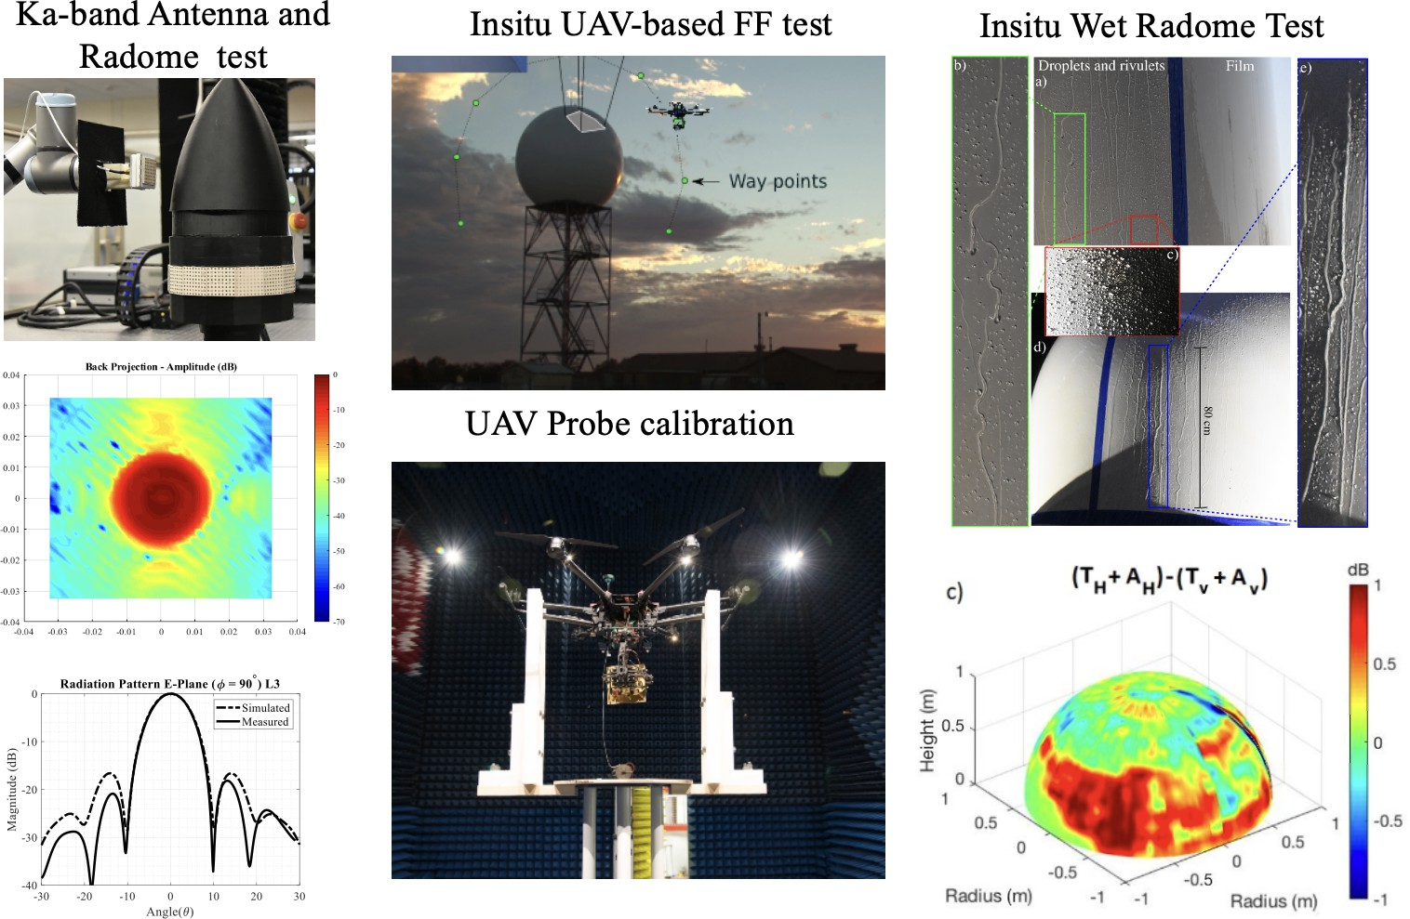
Figure 1: Caption should be concise description should be provided to clearly explain what the figure represents, including any relevant details that help the reader understand the context. If the figure is adapted from another source, an in-text citation must be included immediately after the caption, following IEEE referencing style. Consistency in formatting is essential throughout the paper, as using the same style for all figure captions enhances the overall professionalism of the document. This figure serves as an example of a clustered representation of the results obtained. It is essential to ensure that the font size of the axes and labels is sufficiently large to be easily readable [4].

Important Considerations

Abbreviations and Acronyms
Define abbreviations and acronyms the first time they are used in the text, even after they have been defined in the abstract. Abbreviations such as IEEE, SI, MKS, CGS, ac, dc, and rms do not have to be defined. Do not use abbreviations in the title or heads unless they are unavoidable.

Units
The template is designed so that author affiliations are not repeated each time for multiple authors of the same affiliation. Please keep your affiliations as succinct as possible (for example, do not differentiate among departments of the same organization). This template was designed for two affiliations, but can be customized for fewer or more as described below.
  - Use either SI (MKS) or CGS as primary units. (SI units are encouraged.) English units may be used as secondary units (in parentheses). An exception would be the use of English units as identifiers in trade, such as “3.5-inch disk drive”. Avoid combining SI and CGS units, such as current in amperes and magnetic field in oersteds. This often leads to confusion because equations do not balance dimensionally. If you must use mixed units, clearly state the units for each quantity that you use in an equation.
  - Do not mix complete spellings and abbreviations of units: “Wb/m²” or “webers per square meter”, not “webers/m²”. Spell out units when they appear in text: “. . . a few henries”, not “. . . a few H”.
  - Use a zero before decimal points: “0.25”, not “.25”. Use “cm³”, not “cc”.)

Equations
Number equations consecutively. Italicize Roman symbols for quantities and variables, but not Greek symbols. Use a long dash rather than a hyphen for a minus sign. Punctuate equations with commas or periods when they are part of a sentence, as in:
$a+b=γ$ 
Be sure that the symbols in your equation have been defined before or immediately following the equation. Use “(1)”, not “Eq. (1)” or “equation (1)”, except at the beginning of a sentence: “Equation (1) is...”
Figure 2: Caption Example: Numerical simulation using an infinite array approach in Ansys HFSS for an X-band pyramidal absorber, analyzing its performance as a function of incident angle across various absorber materials. The electrical prop- erties of the absorber were optimized to achieve reflectivity values of -20 dB, -30 dB, -40 dB, and -50 dB.

Some Common Mistakes
  - The word “data” is plural, not singular.
  - The subscript for the permeability of vacuum µ0, and other common scientific constants, is zero with subscript formatting, not a lowercase letter “o”.
  - In American English, commas, semicolons, periods, question and exclamation marks are located within quotation marks only when a complete thought or name is cited, such as a title or full quotation. When quotation marks are used, instead of a bold or italic typeface, to highlight a word or phrase, punctuation should appear outside of the quotation marks. A parenthetical phrase or statement at the end of a sentence is punctuated outside of the closing parenthesis (like this). (A parenthetical sentence is punctuated within the parentheses.)
  - A graph within a graph is an “inset”, not an “insert”. The word alternatively is preferred to the word “alternately” (unless you really mean something that alternates).
  - Do not use the word “essentially” to mean “approximately” or “effectively”.
  - In your paper title, if the words “that uses” can accurately replace the word “using”, capitalize the “u”; if not, keep using lower-cased.
  - Be aware of the different meanings of the homophones “affect” and “effect”, “complement” and “compliment”, “discreet” and “discrete”, “principal” and “principle”.
  - Do not confuse “imply” and “infer”.
  - The prefix “non” is not a word; it should be joined to the word it modifies, usually without a hyphen.
  - There is no period after “et” in the Latin abbreviation “et al.”.
  - The abbreviation “i.e.” means “that is”, and the abbrevi- ation “e.g.” means “for example”.

Recommendations for Figures
  - Use High-Quality Figures: Ensure all figures are clear, high-resolution, and easily readable (preferably 300 dpi or higher). Preferable to use vector formats (e.g., EPS, or PDF) for diagrams and graphs to maintain clarity when resized.
  - Consistent and Professional Style: Maintain a uniform style for all figures, including consistent font sizes, line thicknesses, and color schemes. Avoid overly complex or cluttered visuals.
  - Label Clearly: Include descriptive titles, clear axis la- bels, legends, and numbered captions (e.g., “Figure 1: Caption explaining the figure”). Ensure all elements in the figure are readable, even when printed in black and white.
  - Placement Close to Reference: Place figures as close as possible to where they are discussed in the text for ease of understanding. Avoid placing them on separate pages unless necessary.
  - Optimal Positioning: Figures are desirable to be placed at the top of the page. Figures in the middle or bottom sections are not acceptable, as they can disrupt the flow of the text.

Recommendations for Table Format
  - Optimal Positioning: Figures are desirable to be placed at the top of the page. Figures in the middle or bottom sections are not acceptable, as they can disrupt the flow of the text.
  - Provide Informative Captions: Each table must have a concise, self-explanatory caption placed above the table (e.g., “Table 1: Caption explaining the table”).
  - Use Consistent Style: Ensure tables are styled consistently throughout the paper, with uniform font sizes and alignment. Use a sans-serif font like Helvetica or Arial, as recommended by IEEE.
  - Reference Tables in Text: Refer to all tables in your text (e.g., “As shown in Table 1...”), and place tables close to where they are discussed for better readability.
  - Optimal Placement: Tables are desirable to be placed at the top of the page. Avoid placing them in the middle or at the bottom of the page, as it may disrupt the flow of the paper.
  - Column Alignment: Align numeric data to the right for easy comparison, while text data can be left or center aligned. Use proper spacing to avoid overcrowding.

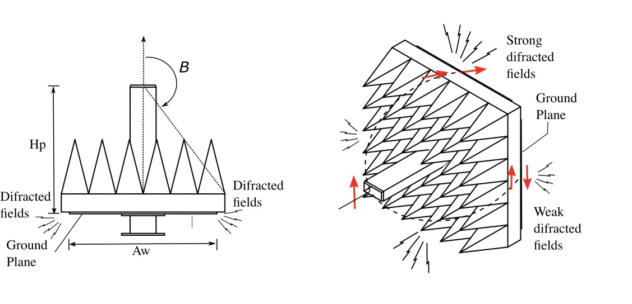
Figure 3: Caption should be concise description should be provided to clearly explain what the figure represents, including any relevant details that help the reader understand the context. If the figure is adapted from another source, an in-text citation must be included immediately after the caption, following IEEE referencing style. Consistency in formatting is essential throughout the paper, as using the same style for all figure captions enhances the overall professionalism of the document.

Table I: Example of Table Caption: Summary of induced ripple and cross-polarization on Far-field antenna patterns of a probe in X-band with different collar absorber conditions

 | Refl. (0o) | Refl. (60o) | Ripples Co-p  (peak-peak) | X-p  (ave)
Not ABS | – | – | ± 5.0 dB | -35 dB
ABS-20 | -20 dB | -32 dB | ± 1.10 dB | -45 dB
ABS-30 | -30 dB | -32 dB | ± 0.20 dB | -42 dB
ABS-40 | -40 dB | -29 dB | ± 0.15 dB | -42 dB
ABS-50 | -50 dB | -25 dB | ± 0.12 dB | -43 dB

Conclusions
Recap the primary results and contributions of your research to reinforce the significance of your work to the reader. Explain how your findings can be applied in real-world scenarios or how they advance the field to add value to your research. Mention any limitations of your study to demonstrate a critical understanding of your work and set the stage for future research. Offer ideas for future research directions that build on your findings to encourage ongoing exploration in your area of study. Finish with a thought-provoking statement or a call to action that emphasizes the importance of your research and its potential impact on the field.

Acknowledgement
The preferred spelling of the word “acknowledgment” in America is without an “e” after the “g”. Avoid the stilted expression “one of us (R. B. G.) thanks . . .”.

References
- Hindman, G, Newell, A.C., “Reflection Suppression in a large spherical near-field range”, AMTA 27th Annual Meeting & Symposium, Newport, RI, Oct. 2005.
- J. L. Salazar, N. Aboserwal, J. D. D´ıaz, J. A. Ortiz and C. Fulton, “Edge diffractions impact on the cross polarization performance of active phased array antennas,” 2016 IEEE International Symposium on Phased Array Systems and Technology (PAST), Waltham, MA, USA, 2016, pp. 1-5, doi: 10.1109/ARRAY.2016.7832571.
- J. L. Salazar et al., “An Ultra-Fast Scan C-band Polarimetric Atmo- spheric Imaging Radar (PAIR),” 2019 IEEE International Symposium on Phased Array System and Technology (PAST), Waltham, MA, USA, 2019, pp. 1-5, doi: 10.1109/PAST43306.2019.9021042.
- J. L. Salazar et al., “Advancements in Measurement and Calibration of Multifunction Phased Array Radars: Exploring Future Research Direc- tions,” In Proceedings of the European Conference on Antennas and Propagation (EuCAP) 2025, pp. 12-16. Stockholm, Sweden, between March 30 and April 4, 2025., doi: 10.1109/PAST43306.2019.9021042.
- E. Martini, O. Breinbjerg and S. Maci, “Reduction of Truncation Errors in Planar Near-Field Aperture Antenna Measurements Using the Gerchberg-Papoulis Algorithm,” in IEEE Transactions on Antennas and Propagation, vol. 56, no. 11, pp. 3485-3493, Nov. 2008, doi: 10.1109/TAP.2008.2005442.
- N. A. Aboserwal, J. L. Salazar, J. A. Ortiz, J. D. D´ıaz, C. Fulton and R. D. Palmer, “Source Current Polarization Impact on the Cross- Polarization Definition of Practical Antenna Elements: Theory and Applications,” in IEEE Transactions on Antennas and Propagation, vol. 66, no. 9, pp. 4391-4406, Sept. 2018, doi: 10.1109/TAP.2018.2845945.
- A. D. Yaghjian, Upper-bound errors in far-field antenna parameters determined from planar near-field measurements, National Bureau of Standards Tech. Note 667, October 1975.
- Francis, M. and Wittmann, R. (2008), Near-field Scanning Measure- ments: Theory and practice, Modern Antenna Handbook.
- Newell, S. Gregson, D. Gentle, P, Miller, “The Effect of the Absorber Collar on Open Ended Waveguide Probes”, AMTA 2009.

